create table bank(bankcode varchar(3),bankname varchar(30) not null,headoffice varchar(30), branches int not null check(branches>0), primary key(bankcode));

insert into bank values('SBT','SBI Bank','Delhi',30);

insert into bank values('CNB','Canara Bank','Ernakulam',20);

insert into BANK values('SIB','South Indian Bank','Madras',30);

insert into bank values('AXB','Axis Bank','Kottayam',15);

insert into BANK values('FDB','Federal Bank','Ernakulam',25);

select \* from bank;

commit;

insert into bank values('UBI',' Union Bank of India','Delhi',30);

insert into bank values('UOI',' Union Bank of India','Delhi',30);

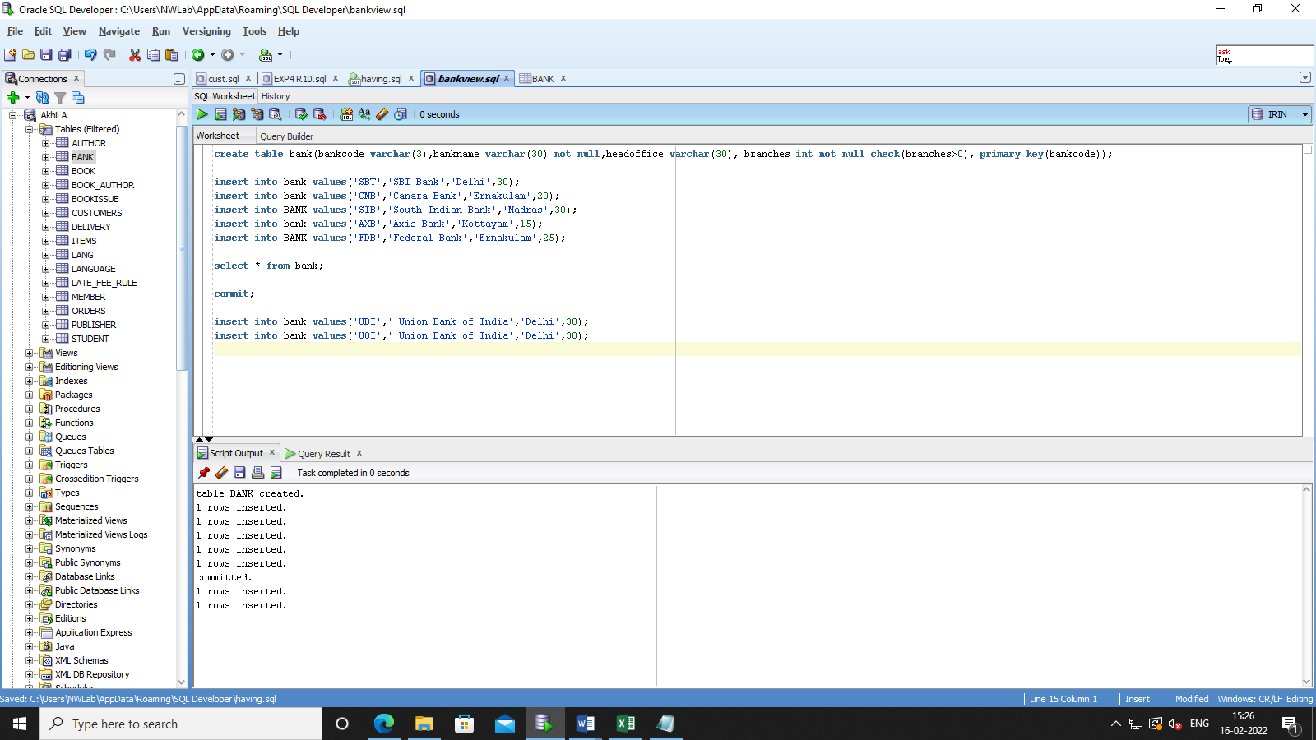

rollback

select \* from bank;

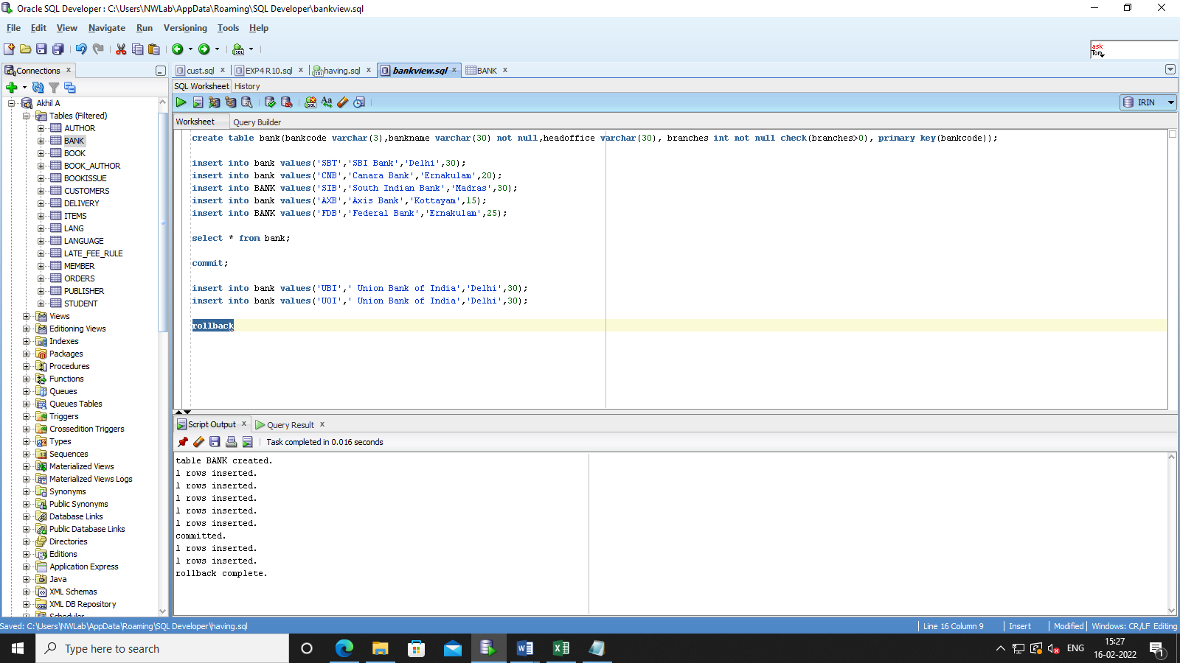 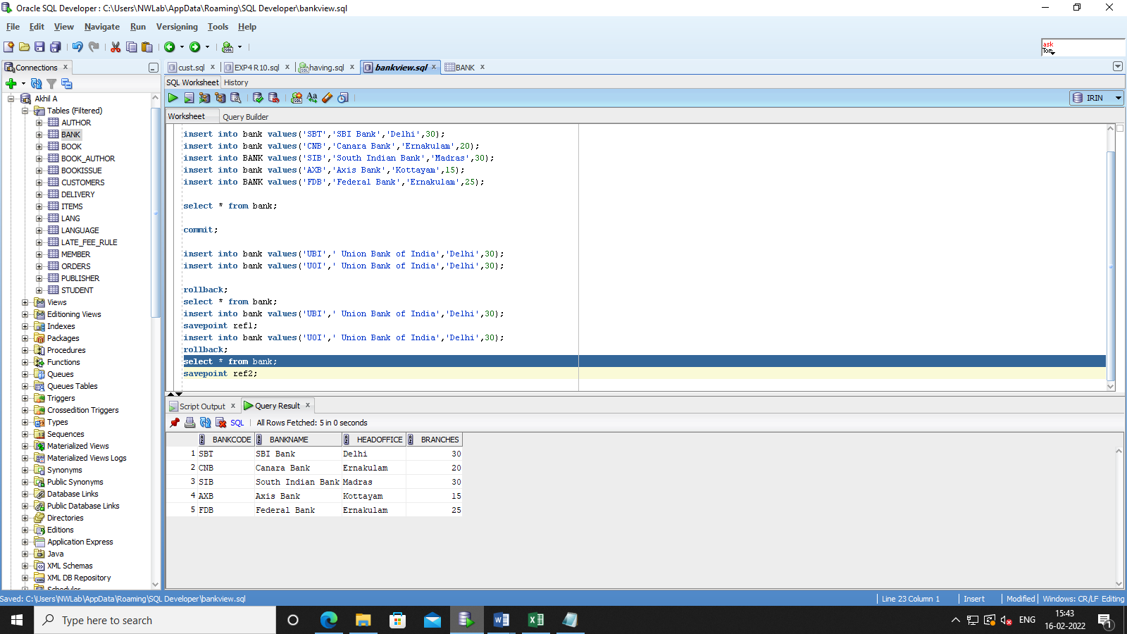

insert into bank values('UBI',' Union Bank of India','Delhi',30);

savepoint ref1;

insert into bank values('UOI',' Union Bank of India','Delhi',30);

rollback ref1;

select \* from bank;



insert into bank values('FOI',' Union Bank of India','Delhi',30);

savepoint ref2;

rollback to ref2;

select \* from bank;

